Вариант 1

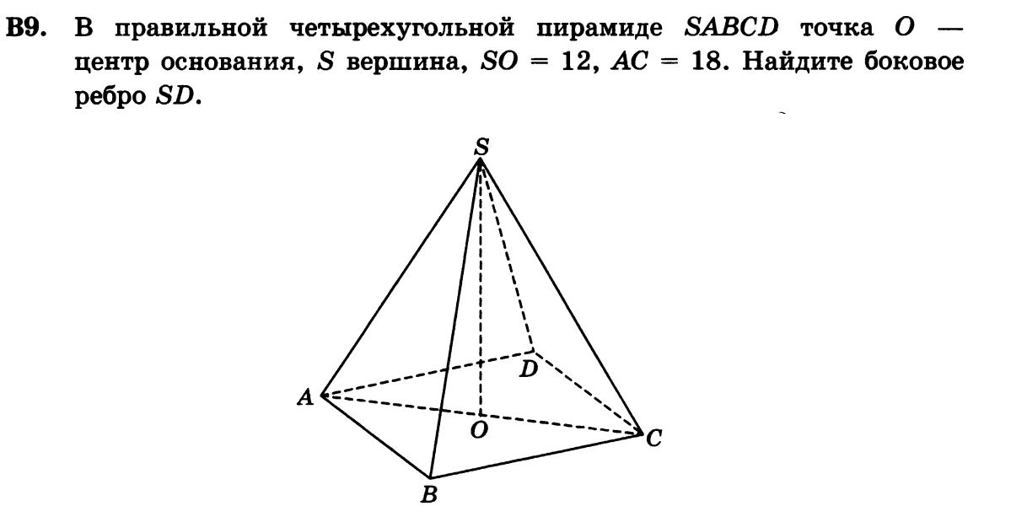

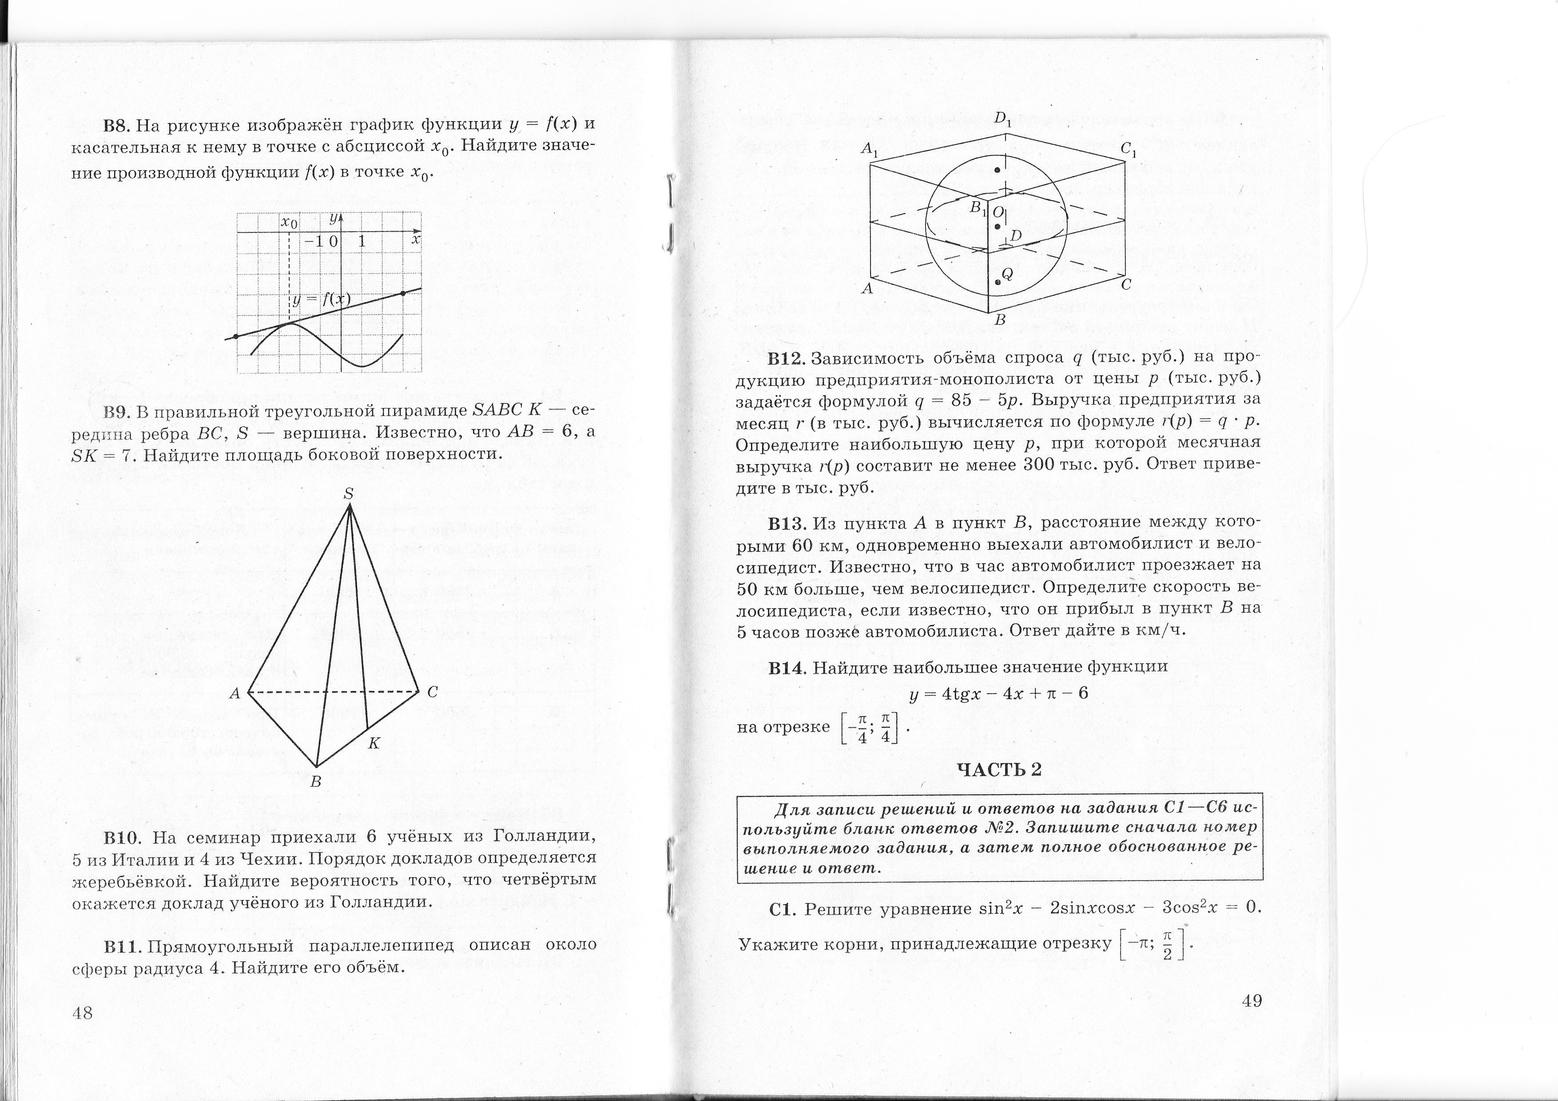__________________________________________________________________________________________________

Вариант 2







